With all of our findings, datasets, and research into the subject at hand, the goal of our project is to give everyone the ability to find Covid-19 related information on the fly. For example, before we go out for a task, we tend to check either weather, google maps, or our texts for information before departing. We can add our Covid-19 Hotspot detection app to that list.

* Feature 1 would be to show and highlight the number of testing facilities in a given location.
* Feature 2 would be to have an interactive map in which people can enter any address and have it show them a live covid map of that area
* Feature 3 would be to have different colors on the map represent different stages or things about covid.
* Feature 4 would be to show the different options to get help and relief from.
* Feature 5 would be to connect family together via video chat.
* Feature 6 would be a reminder tab.
* Feature 1 would be to show and highlight the number of testing facilities in a given location.(Toby,Hemdeep)
* Feature 2 would be to have an interactive map in which people can enter any address and have it show them a live covid map of that area(Hemdeep,Dhruv)
* Feature 3 would be to have different colors on the map represent different stages or things about covid. (Toby, Dhruv)
* Feature 4 would be to show the different options to get help and relief from.

(Toby)

* Feature 5 will help people isolated during the pandemic to continue receiving contact with their family and friends in a safe manner. This will promote a healthy alternative during this lockdown. (Dhruv)
* Feature 6 would be a reminder tab that is dedicated to all the safety measures that everyone can take to stop the spread of Covid 19.(Hemdeep)

**Feature 1 would be to show and highlight the number of testing facilities in a given location.**

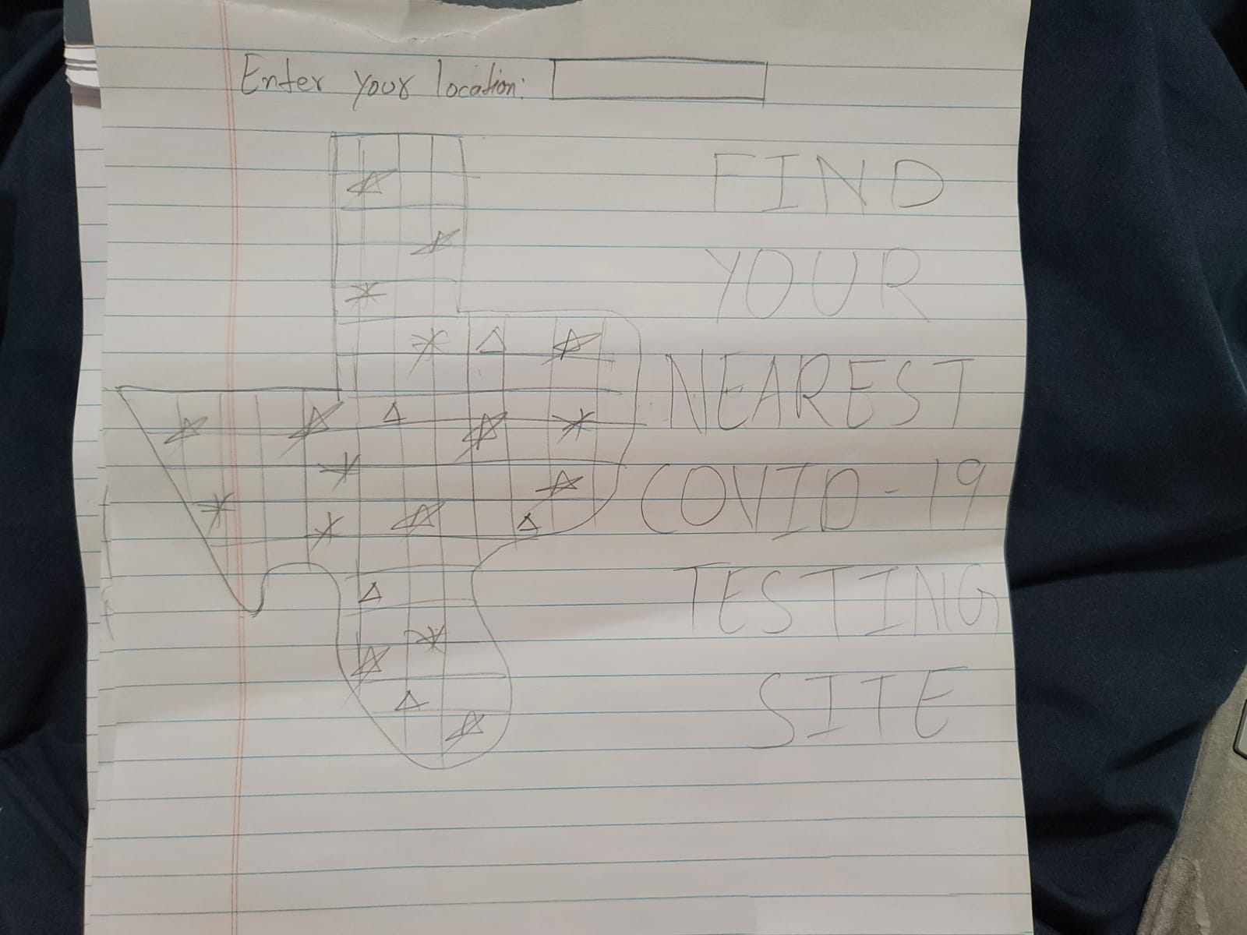

**This interface includes the location tab where the user enters the location of the area where the interface displays the nearest testing facilities.**

**Feature 2 would be to have an interactive map in which people can enter any address and have it show them a live covid map of that area.**

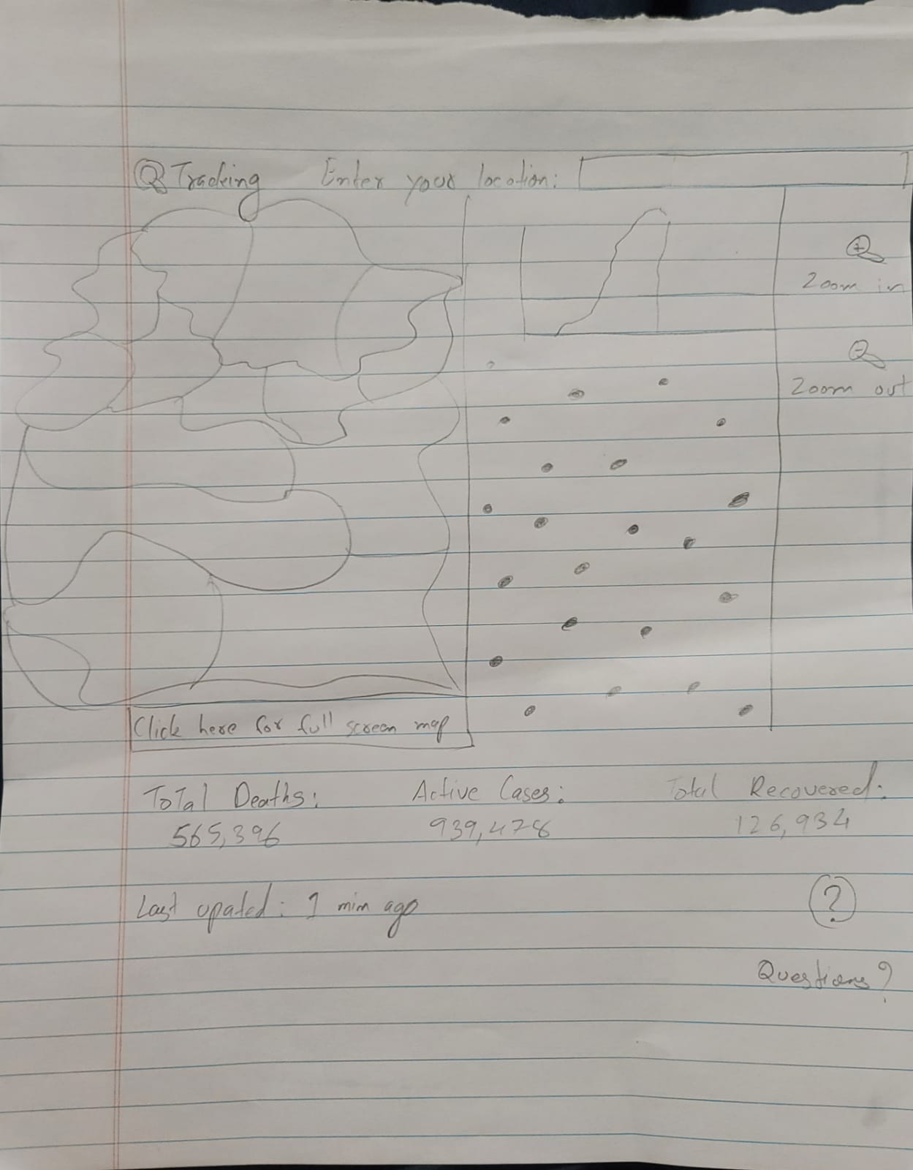

**This interface includes the location tab where the user enters the location of the area and the interface displays live covid counts in that particular area. It displays the death counts, active cases and recovered cases in that area.**

**Feature 6 would be a reminder tab that is dedicated to all the safety measures that everyone can take to stop the spread of Covid 19.**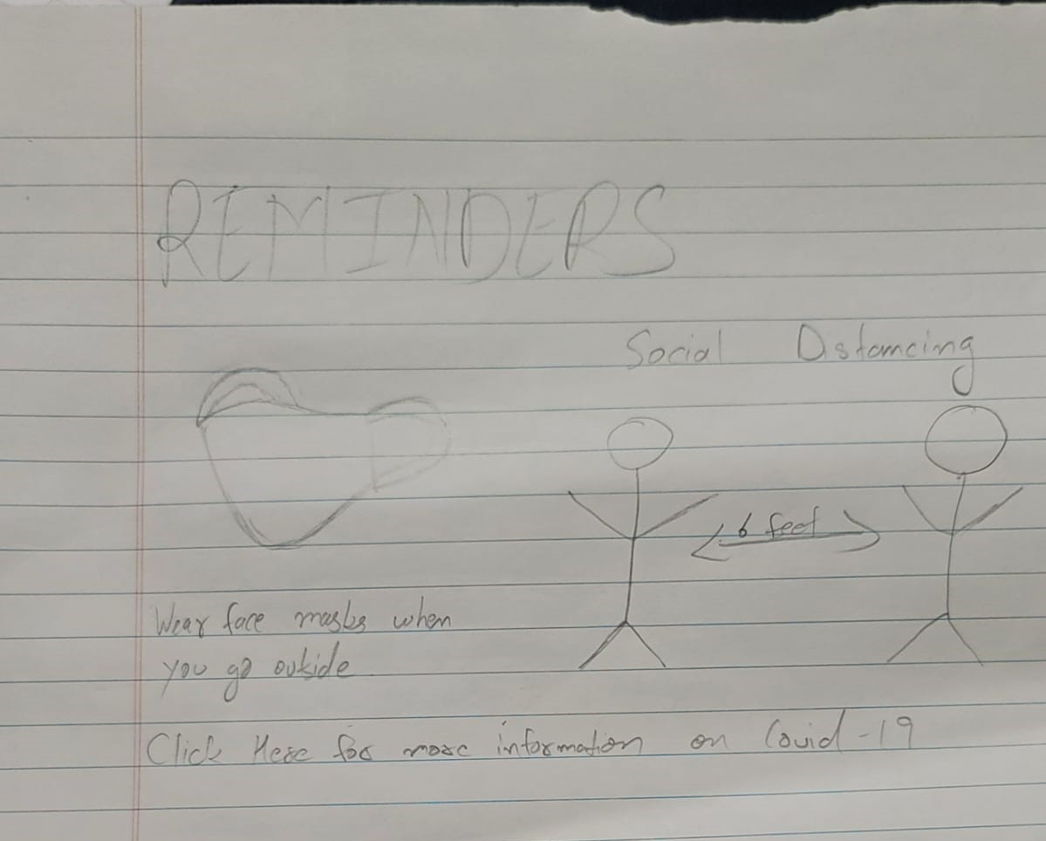

**This interface includes the reminder tab where the user can click and it will redirect them to a reminder page where they are reminded some of the basic measures that they can take to help the spread of the virus such as wearing masks and social distancing.**